Please Support…Please Support….Please Support….Please Support

Westernport and Peninsula Protection Council Inc.

Founded in 1971, the programs of the Council are aimed at preserving and restoring our precious natural environment in Westernport Bay and its hinterland. An important part of our activities is to ensure that proper planning processes are observed by Government at all three levels and that community consultation is a fundamental component of planning.
Prompting community awareness of important conservation issues has also been high on our agenda for the past 50 years.
The activities of Council are managed by a committee elected at the annual General Meeting, which is held on a Sunday early in January.
Additional help on the Committee and in a range of other ways is always welcome. Please indicate on the subscription form if you have any special skills or interests which may be helpful in our campaigns.
For further information about our activities please contact: President Louise Rawlings: social media 0418 271504, Karri Giles: secretary/editor 59 832 072, Sandy Milne editor 0419 333 959

I would like to support the work of Westernport Peninsula Protection Council Inc.
Subscription: (not tax deductible) - subscriptions fall due 1st Nov each year
$10 individual $15 family $………
Donation: (tax deductible for amounts of $2 or more - see below) $……….

Internet transfer Westernport and Peninsula Protection Council.
NAB Hastings BSB 083-668
Account number: 02580 2659
Include your name, or email with the same details as below on wppcweb@gmail.com so we can send a receipt and include you on our mailing lists
Or send a cheque:
I/we enclose a cheque for: $______ Donation $_________
Name: ……………………………………………………………………………
Address:………………………………………………………………………….Postcode:……………….
Phone:……………………………………………
Do you want your newsletters by email? Email:…………………………………….
Please correspond by email: …….. Please send newsletters by email: ………..
Skills/interests: I would like to offer help in the following ways:
……………………………………………………………………………………………………………
Please return to: Hon Treasurer, WPPC, Box 9, Hastings, Vic 3915

The Westernport Peninsula Protection Council Inc Trust is a gift fund listed on the Register of Environmental
Organisations under Section 78(1) (a) of the Income Tax Assessment Act 1936. Inc. no: A0015886H

Westernport and Peninsula Protection Council Inc
Newsletter December 2021
AGM and 50th Anniversary Celebration
Sunday 9th January 2022
10.30am followed by lunch /or on Zoom
Balnarring Hall Frankston-Flinders Rd
please RSVP for lunch - or zoom link to wppcweb@gmail.com
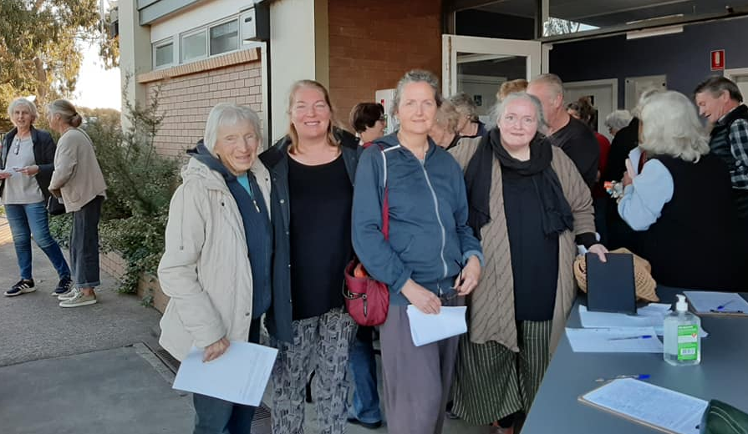
WPPC key contributors to Save Westernport Woodland’s Public Meeting in Corinella May 2021 This is the most exciting campaign going on now

Increasing risk of marine pests in Westernport Bay due to hydrogen export trials – so WPPC acts, underwater and above
Kawasaki Heavy Industries Limited has agreed to conduct a program of surveys for marine pests as part of their Hydrogen Energy Supply Chain Project. This comes after requests from eight environmental groups, led by Westernport and Peninsula Protection Council (WPPC).
We welcome Kawasaki’s agreement to ensure marine pest surveys at the site. Early detection is the only hope for eradication. Other recent surveys show the two most significant pests, Northern Pacific Seastar (Asterias amurensis) and (Undaria pinnatifida)- Japanese kelp, both introduced regionally by ships from Japan, have not been found in Westernport. If introduced, these pests could prove devastating to the Bay’s diversity, ecology, fish stocks and water quality.
We don’t want ships from Japan, as a high-risk port, entering Westernport to export hydrogen long-term because of the risk of introducing these serious marine pests, which have already been introduced to Port Phillip Bay. Other international ports also have these pests.
WPPC and Save Westernport have just completed marine pest surveys at Yaringa Boat Harbour and Stony Point Jetty. These surveys were funded by a grant through Hon Greg Hunt MP’s Office and conducted by Fathom Pacific Pty Ltd, in September 2021. “I am delighted that funding from the Federal Government’s Communities Environment Programme has enabled this important project to be completed and I am glad that the surveys found no evidence of these significant marine pests in Westernport Bay.” The Hon Greg Hunt MP.
Dr Adrian Flynn from Fathom Pacific says: “Western Port is largely free of high priority marine pests of concern in Victoria…Increased shipping activity and recreational boating in Western Port has the potential to increase the risk of marine pest introductions. Therefore, surveillance and monitoring should increase commensurate with the increasing risk.”

WPPC and Save Westernport Action on Marine Pests due to Hydrogen Export Trial – cont.
The Commonwealth Community Environment Program grant to WPPC was initially intended to survey under BlueScope pier, the site of the HESC Hydrogen export trial. The grant was specifically planned to look for marine pests before Hydrogen ships from Japan arrived. When BlueScope refused access for the project, the grant survey was changed to new locations.
In the past, BlueScope’s parent company BHP was involved in trials to heat ballast water to kill organisms, demonstrating concern about the risk of commercial shipping spreading marine pests.
The Victorian Government has also recently surveyed for marine pests at San Remo and Hastings Marina under Richard Stafford-Bell’s team at Agriculture Victoria. These results, together with citizen science surveys at Flinders, Point Leo, and Merricks, completed as part of WPPC and Save Westernport’s project, indicate that the marine pest of highest significance was Pacific oysters. While this species is of concern, it is far less voracious and not as rampant as other introduced species. We need to learn from the mistakes of the past. Woodchip ships have brought in ‘Japanese kelp’ (Undaria pinnatifida) and Northern Pacific seastar, believed to have been spread by hull and ballast water, dramatically degrading Port Phillip Bay and parts of Tasmania. Port Phillip Bay increased from zero to 165 million Northern Pacific seastar between 1997 and 2000, which then ate out their food supply over vast areas in Port Phillip Bay. We must protect Westernport from being carpeted by millions of seastars or blanketed by Japanese kelp or both. Undaria was found once at Flinders and Northern Pacific seastar at San Remo and both eradicated at once. Early detection is vital. For more information - https://www.marinepests.gov.au/pests/identify/japanese-kelp .
We welcome plans to monitor for marine pests at the BlueScope pier at the site of the HESC pilot project. We urge the State and Federal Governments to reject plans for a commercial stage to this hydrogen export pilot project, because the threat of marine pests, and dredging for deeper draught ships is too great.
Environmental groups have been told that ships of deep draught would be used for a commercial stage, which would mean possibly prohibitive amounts of dredging. The $500 million project to convert brown coal to hydrogen is by no means a green energy project. $100 million towards the trial is funded by Australian taxpayers – there’s no future in brown hydrogen, and it is putting Westernport Bay at risk, money that would be far better invested in truly valuable “green energy” projects that protect our future, and that global energy markets increasingly demand.

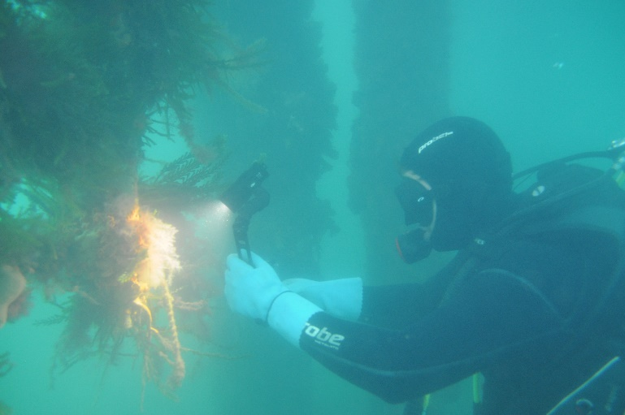 Fathom Pacific conducting marine Pest monitoring under Stony Pt Pier | 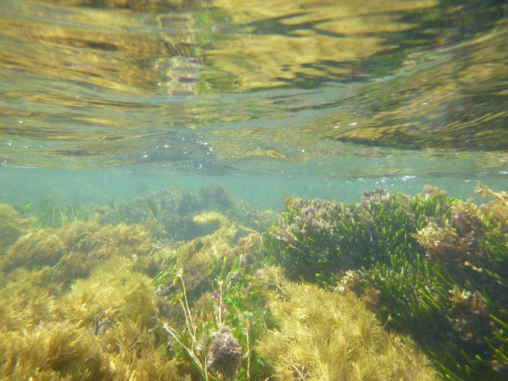  Citizen Science snorkels were undertaken at Merricks, Pt Leo, and Flinders
Westernport’s passionate protectors – 50 years and still going strong!
As we celebrate our 50th year, we’ve put together a timeline of WPPC activities. We reflect on, thank, and acknowledge the committed people, past, present, who contributed to WPPC’s legacy. These allies include passionate community members, state-wide, national, and international environmental organisations, universities, scientists, artists, and our members who are concerned to care for and promote Westernport and surrounds as an integrated, protected biosphere.
There have been many proposals including an aluminium smelter, ammonia-based fertiliser plant, and even a nuclear power plant on French Island. As long as land is zoned port-related and the myth of Westernport as a natural deep-water port, Westernport will continue to be subject to these kinds of threats. WPPC and our allies will continue to fight them.
- In 1928, a Royal Commission recommended development of Westernport Bay as an additional Port
- 1960s Premier Henry Bolte aimed to make Westernport the industrial Ruhr of Victoria, with French Island its industrial heartland. BP, Esso and Lysaght establish, (Crib Point BP refinery established in 1965, to 1983), shipping terminals,
- 1963 BP (Australia) bought and later established at Crib Point
- 1965 Bass Strait oil was discovered
- 1970s
- 1970 Aerial Photographs confirm good seagrass cover in Westernport Bay
- A further port developed at Long Island Hastings involving Steelworks, fertiliser, petroleum, and gas fractionation was approved by Bolte
- Planning Minister Hamer established Western Port Regional Planning Authority the first regional authority outside Melbourne
- The Statement of Planning Policy No.1 the first planning policy for Victoria for Westernport recommending Western Port as a port
- Ampol/Sleigh proposed another oil refinery, on Coolart Road, Bittern. Many concerned people / groups united, to establish the ‘Save Westernport Coalition’.
  - 1971 Petitions were collected, and rallies held, including at Melbourne Town Hall where the poet Judith Wright spoke, and 2000 people attended. A petition with 200,000 signatures was filed, protesting the refinery. By mid-1971 the Ampol/Sleigh development was abandoned.
- WPPC formed from the Save Westernport coalition. Foundation members included Dr Bill Carroll, Meredith and Ken Hayes and Joe Tilleard. WPPC was represented on the Westernport Catchment Coordinating Committee and then The Westernport Regional Planning and Coordination Committee for 25 years. The latter was closed by Planning Minister Robert Maclellan, for no expressed reason, in December 1994 (Kennett govt).
- The Save Westernport Coalition produced ‘The Shame of Westernport Speculators Dream … environmental nightmare’
- Australia became a signatory to ‘The Convention on Wetlands of International Importance’, also known as the Ramsar Convention, an international agreement promoting the conservation and wise use of wetlands. The Port Phillip and Western Port region house three Ramsar-listed wetlands – Port Phillip Bay (western shoreline, Western Port, and Edithvale-Seaford Wetlands https://www.ppwcma.vic.gov.au/our-region/water/ramsar-wetlands/
- 1971-1972 Significant Dredging to establish shipping access to Lysaghts Hastings was reported to have generated a widespread turbidity plume (Watson 1974)
1973 The Shapiro Study of Westernport Bay was commissioned under Dick Hamer’s Government, raising concern about a seagrass die-off. ‘A preliminary report on the Westernport Bay environmental study: report for the period 1973-1974’, Maurice A. Shapiro. Victoria. Ministry for Conservation.
1977–79 Proposed Gas Turbine Power Station, Tyabb, Devil Bend Airport - major freight and business jet airport, IPEC Tigers - proposed freight terminal – all abandoned.
1979 WPPC requested Dr Brian Cuming’s assistance as a chemical engineer, and he immediately became involved in hearings of the House of Representatives Oil Spills enquiry.
1980s
1986 - Green’s Bush – WPPC joined a coalition of ecologists and community, to prevent subdivision and establish a nature reserve
1987 Artist Ian Cuming approached WPPC for $300 to make giant puppets representing marine life in the bay. This grew into The Seagrass event, using over $110,000 grant money from local, State and Federal Government through 1988-90. WPPC was deeply involved, with local community and hundreds of school children. So to was Prue Griffith, and Rosey Buchanan, (WPPC) subsequently became a local councillor and MP respectively.
WPPC gave a small environmental award to a Westernport College student every year until the 2000s
1987 - Proposed Western Mining ammonia-urea plant was stopped.
1990
1991 Seagrass story, 1991 https://www.youtube.com/watch?v=b3Ov6eS5170 , Ian Cuming
1993 WPPC’s Prue Griffiths submission on oil spill accidents
1994-1997 Shell/Mobil proposal for ‘supertankers’ to ship crude oil terminal at Woolleys Beach.
1995 - Oil in Westernport Position Statement written by Brian Cuming, President WPPC after lengthy research by the committee, including a requirement for EES re large scale oil imports through Crib Point.
- WPPC submission to The Standing Committee on Transport, Communication and Infrastructure: “Is Australia ready to respond to a major oil spill?”
- An oil spill model, using Mark Marsden’s work in the Environmental Study of Westernport Bay (Shapiro), WPPC highlighted how quickly an oil spill would spread through the strong tidal bay, and how contemporary practice couldn’t contain it.
- Brian Cuming spoke to The Ceo of Shell in Europe and was told that Crib Point Shell Mobil supertankers would not go ahead as business case didn’t stack up.
- WPPC, with Dr Brian Cuming’s leadership saved BHP land in Bittern that was being subdivided for Kinfauns Estate and reserved a large amount of it as Warringine Park with a structure for community involvement.
1996
- Karri Giles, WPPC attended the Ramsar conference in Brisbane as a Friends of The Earth Delegate that year and spoke to Richard Hill Federal Environment Minister in a meeting of NGOs. WPPC, Alistair from ACF, and other NGO’s recommended the Secretary General, Ramsar Convention Bureau, that Westernport Site be placed on the Montreux Record, due to oil spill danger and other ecological issues.
- Hastings Council Resolution unanimously called for Environmental Impact Assessment of oil imports
- Aust. Sea Freight/Bond family- Marine Precinct Park, “The Bluff” proposal, 4 large berths with storage facilities and a concrete causeway into the bay, “A Development Proposal for a public facility at The Bluff Western Port Victoria”, prepared by Maunsell, who later prepared the Victorian Port Strategic Study recommending The Bluff as a site for port development.
1999 WPPC advised through its networks that Melbourne Water would decommission Bittern and Devilbend Reservoirs in 2001, with a proposal to effectively sell off half the land for subdivision. Snez Plunkett, (WPPC) Shire Councillor, was actively involved in highlighting the issue and spent 3 years on Melbourne Water’s Devilbend community consultative committee.
2000s
The beginning of a seventeen-year campaign against a container port in Westernport Bay. WPPC wrote a submission on the Victorian Ports Strategic Study.
Mangroves and Saltmarsh at The Bluff were bulldozed, and the Bond family were fined.
2002 Marine National Parks Proclaimed including French Island, Yaringa and Churchill Island in Westernport
2003 ‘The Community Vision for Devilbend’ is launched by WPPC Inc. at a Public Meeting hosted by WPPC 28th May at Moorooduc Hall. Unanimous vote to keep it in public hands. A winter solstice gathering at Devilbend was then held, involving WPPC, as was a spring picnic at Devilbend.
- 2004 WPPC hosted an Autumn Equinox Clean Water-Cycle event at Devilbend
- A Devilbend Reservoir Community Workshop at Mornington Racecourse, arranged by Parks Vic, DSE, Melb Water & MPSC and included 40 enviro & community groups, and Bunurong representatives.
- This coalition formed the beginnings of the Westernport Biosphere committee.
- Campaigning continued for another 3 years.
- Successful advocacy with MP Shire to preserve wildlife corridor and walking track along Warringine Creek, linking to Warringine Park.
2005 The Devilbend Steering Group was formed, with 40 groups
2006 Devilbend announcement – 100% of Devilbend / Bittern reservoirs set aside for community parkland, for passive recreation and nature conservation!!
For many years WPPC presented an Environmental Scholarship to Westernport Secondary College.
2009 - Boral Construction Materials proposes to construct a bitumen storage facility and associated infrastructure at Crib Point. Initially approved by the Victorian Minister for Planning. WPPC supported Crib Pt action Group, Neale Burgess and others in overturning this decision.
2010s
2011 –Baillieu government announced expansion of Port of Hastings, catapulting WPPC and allies into busy campaigning
2013- Oil Spill modelling updated for VNPA and WPPC
2014
- WPPC’s Karri Giles met with The Ramsar Secretariat in Switzerland who later came to Hastings and met with environment groups and Federal Environment Minister about Westernport Bay
- Estimating the value of Westernport Bay- a study of Westernport Bay’s measurable economic value’ by ACF’s New Economics Advisory Service commissioned by WPPC and VNPA based on Robert Costanza’s work found Westernport Bay to be worth up to $2.6 Billion per year
- ‘Impact of Proposed Hastings Port Expansion on Seagrass Mangroves and Saltmarsh’, Kirkman- Commissioned by WPPC and VNPA
- WPPC, EV, Quit Coal, Blue Wedges, Preserve Westernport Rally at Hastings re bulk Coal export
- WPPC spoke at Rally in Melbourne hosted by EV, FOE, Quit Coal on container port and coal export dock proposal
- Co-hosted with VNPA Seminar on Environmental Economics Valuing Westernport featuring Professor Robert Costanza to promote work n the economic value of the bay (above), followed by a vision exercise hosted by VNPA, Preserve Westernport, Australian National University, Bass Coast Shire Council and led by Professor Robert Costanza, Environmental Economist, attended by many Westernport residents, government officers and professionals over 5 days at Newhaven.
2015
- WPPC Co-hosted ‘Bay on the Brink’ with Birdlife Australia, VNPA and Blue Wedges, focused on the impact of proposed Port of Hastings expansion on seagrass, mangroves, saltmarsh and birdlife.
- the PPWCMA commissioned the ‘Distribution and Abundance of Blue Carbon in Port Phillip and Westernport Bay.

2017
- Infrastructure Victoria provided advice to state Government that Westernport was less socially, economically, and environmentally suitable for Port expansions than BayWest…and that no significant expansion would be needed by Victoria until 2040.
2018
- GHD informed WPPC that a Japanese consortium was planning to convert brown coal to hydrogen and export it out of Hastings.
- WPPC, Save Westernport, VNPA, EV, Blue Wedges rally against AGL and the hydrogen export proposal
- Sent a joint letter from eight environment groups to Kawasaki and BlueScope, requesting marine pest monitoring as part of the hydrogen export trial at Hastings
2017- 2020
- WPPC worked closely with Save Westernport, Environment Victoria, VNPA and many local groups, on the successful campaign to oppose AGL’s proposal for a floating gas storage rectification unit at Crib Point, with associated pipeline through Westernport wetlands, hinterland, and farming land. WPPC provided an expert witness, Dr Mary Cole, to speak on the significant risk of chytrid fungus to asparagus farming, Karri Giles on risks to amphibians and to Watsons Creek, Gidja Walker on risk to ecology of wetlands and surrounding hinterland and Sandy Milne on swamp skinks and risk of feral pest corridors.
2020
- WPPC worked with Save Westernport (SWP) to receive a grant through Greg Hunt’s office to monitor marine pests under BlueScope pier. Hosted a marine biologist to explain our citizen science project to identify marine pests in Westernport Bay
2021
- After being refused access by BlueScope, WPPC and SWP met with Kawasaki, who announced that they would execute marine pest monitoring at BlueScope pier.
- Executed the marine pest monitoring grant at Yaringa and Crib Pt
- Submission to MP Shire’s 2040 vision document, with Save Westernport.
- Met with a coalition of groups to develop a strategy for greater protection of Westernport
- Supporting the Save Arthur’s Seat and Westernport Woodlands and Green Wedges Coalition in their campaigns against expanded quarrying and sandmining in pristine bushland areas.
- Breaking news!!!! The Save Arthur’s Seat campaign has been successful! The RE Ross Trust has made a good decision to withdraw its plan to expand its quarry there.
A big thank you - To the Ruffin/Falkner Foundation for a grant to help us secure information from the Crib Pt AGL IAC archive for education and reference purposes.

 | The most exciting campaign to join right now  In one of the most cleared regions of the most cleared state in Australia, the forest corridor near Grantville, on the east side of Westernport is so diverse. It is worth looking on Google Maps to see how little remains.  Around 40 per cent of the area is designated as an 'Extractive Industry Interest Area'. 500 years’ worth of sand is earmarked in the area. The areas outside of bush reserves are sufficient to supply sand.  ​ It is right on the doorstep of brand-new suburbs (many without back gardens) and should be a  wonderful asset for conservation, recreation, and education.  Download this important report which outlines the valuable ecology or email savewesternportwoodlands@gmail.com for a hard copy. published by the Victorian National Parks Association in association with Save Western Port Woodlands, Western Port Woodlands – wildlife corridor or sand pit? - Victorian National Parks Association Victorian National Parks Association (vnpa.org.au) | Western Port Woodlands – wildlife corridor or sand pit? - Victorian National Parks AssociationVictorian National Parks Association (vnpa.org.au)

Thank you for your continued support! Please tell others about our website and face book pages… and let us know your thoughts and ideas. All the best for the festive season.
email: wppcweb@gmail.com Facebook, Westernport and Peninsula Protection Council or website: https://www.wppcinc.org
Please send your email address to wppcweb@gmail.com if you would prefer to receive our annual newsletter by email. Please don’t forget to pay your membership.

‘Pest’ fears over hydrogen exports
BY KEITH PLATTDECEMBER 20, 2021UPDATED:DECEMBER 22, 2021NO COMMENTS4 MINS READ
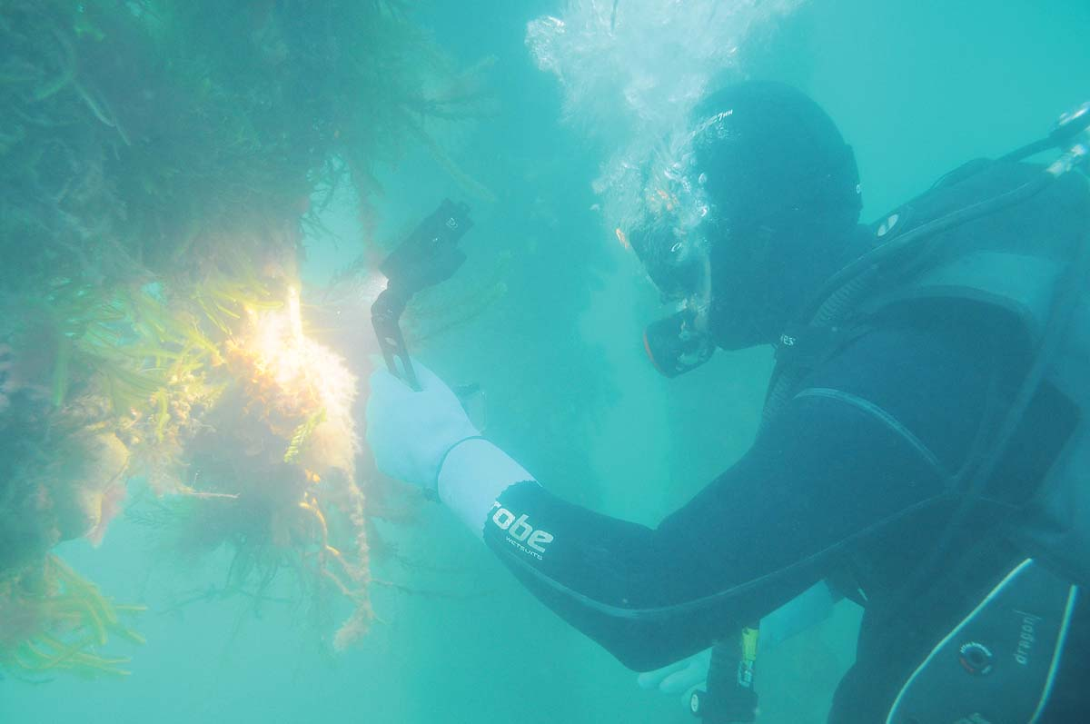
DIVERS are conducting surveys in Western Port to help set benchmarks for monitoring any infestations of marine pests after Hastings becomes a regular destination from Japan for the purpose-built hydrogen carrier ship, Suiso Frontier.
SHARE
FEARS are held overt the export of hydrogen from Western Port leading to the import of marine pests.
Kawasaki Heavy Industries has agreed to conduct surveys to monitor Western Port for marine pests already introduced into Port Phillip by ships from Japan.
The hydrogen being transported from western Port to Japan is being produced from brown coal in the Latrobe Valley, a process that depends for success on carbon being stored underground through CCS (carbon capture and storage).
The hydrogen from brown coal project began more than a decade ago and the state and federal governments each gave $50 million towards the $400m trial. This figure does not include extra money being spent by government on CCS research, which is already under way.
Environment groups including Ninety Mile against Carbon Storage are opposed to CCS and say the “so-called ‘blue hydrogen’ projects that rely on unproven CCS technology would entrench the unnecessary use of fossil fuels in energy production”,
Since the Hydrogen Energy Supply Chain Project (HESC) began, experts, including the CSIRO, have suggested the cost of making hydrogen through renewable electricity powered electrolysis will be competitive if not equal to brown coal by 2025.
“In summary the HECS trial is taking 160 tonnes of brown coal, burning it, producing three tonnes of hydrogen and 100 tonnes of emissions. The trial will offset its emissions by buying carbon credits. The technology to capture the emissions and store them in the Bass Strait has not been finalised, proven or been shown to be economically viable,” former Mornington Peninsula Shire councillor Simon Brooks said (“Brown coal to hydrogen: responsible or risky” The News 12/4/21).
Kawasaki agreed to the marine surveys after requests from eight environmental groups, led by Westernport and Peninsula Protection Council (WPPC), an organisation with 50 years of experience in Western Port.
Early detection was the “only hope” to eradicate northern Pacific seastars (Asterias amurensis) and Japanese kelp (Undaria pinnatifida), said the WPPC’s secretary Karri Giles.
“If introduced, these pests could prove devastating to the bay’s diversity, ecology, fish stocks and water quality,” Ms Giles said.
“We don’t want ships from Japan entering Western Port to export hydrogen long-term because of the risk of introducing these serious marine pests, which have already been introduced to Port Phillip.”
Yaringa Boat Harbour and Stony Point jetty have been given the all clear after marine pest surveys were conducted for the WPPC and Save Westernport by Fathom Pacific.
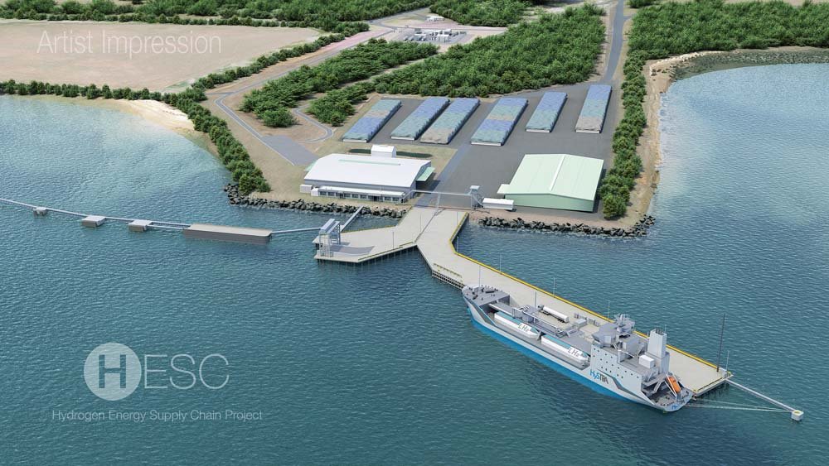AN artist’s impression of a hydrogen transport ship berthed at Hastings. Surveys nare underway to help determine if the ships from Japan would introduce marine pests to Western Port.
The undersea work was carried out by the consulting and research firm that specialises in marine and freshwater areas through a federal government grant.
The company says it is “committed to delivering state-of-the-art solutions and high-quality outcomes”.
Kawasaki Heavy Industries’ senior staff officer Yuko Fukuma said the first of its marine survey would “assess the risk profile of the Port of Kobe, the Port of Hastings and the [hydrogen carrier ship] Suiso Frontier to determine the marine pest risk from the Suiso Frontier travelling between the two ports”.
The 116 metre, 8000 tonne Suiso Frontier, launched in December 2019 as part of the brown-coal-to-hydrogen demonstration project, is expected to arrive in Western Port before March next year.
The first stage of the marine survey looked at the environmental similarities and differences between the ports, such as water temperatures, seabed types, current and nutrient regimes and existing levels of ecological disturbance.
Using those findings as a baseline, the consultants will next investigate what marine pests already exist in Western Port ahead of the Suiso Frontier’s arrival.
“This survey work will be repeated several months after the vessel has departed in 2022 to assess whether any new marine pests have appeared,” Yuko Fukuma said, adding that the results would be “shared” in the second half of 2022.
First published in the Western Port News – 22 December 2021
SHARE.FacebookTwitterPinterestLinkedIn

POSTAGE PAID AUSTRALIA
PRINT POST
PP 344188/10014
If undeliverable return to:
WPPC
PO Box 9
HASTINGS VIC 3915

Westernport & Peninsula
Protection Council Inc

