Cr Antonella Celi
Mornington Peninsula Shire Council
Private Bag 1000
Rosebud 3939

Dear Cr Celi,

Expansion of Port of Hastings

Expanding the Port of Hastings in existing suburbs and in highly-sensitive and highly-valued natural areas would create ecological damage and cost existing industries, and existing jobs.
Many people have jobs in the recreation, tourism, marine/outdoor-education, fishing, surfing, yachting and boating industries.

When we teach our children to surf at Crunchies at Shoreham, when we sail out of Somers, fish at Merricks, when we take school groups out at Balnarring rock platform, when we see Victoria’s premier tourist attraction the penguins on Phillip Island (a tourism industry worth up to $1.9 billion dollars to the Victorian economy), we know what wealth is.

Westernport is Victoria’s marine playground, a unique tidal bay and wetland with remarkable environmental and recreational values right on the fringe of the expanding city of Melbourne. Unlike the large, deep, cold ports of the Northern Hemisphere, Westernport is warm and shallow - so shallow 75% is less than 5m deep (necessitating serious dredging for the channel, swing basins and anchoring sites ) and 42% of it is exposed at low tide. Any oil spilt would coat the tidal mudflats twice a day. Melbourne Water’s Westernport Studies 2011- 2013 have highlighted the risks of killing animals that burrow into the bottom of the Bay with silt or oil spills, as these animals provide a suitable condition for nitrogen in the water to convert to harmless gas. Allowing nitrogen to build up could result in algae blooms and dead zones, which are all too common around the world.

In September last year, conservation groups released new research, which found that even relatively small amounts of oil spilled from shipping traffic in Westernport could reach local shorelines within minutes and high conservation areas within less than six hours.

The research modelled six credible oil spill scenarios based on 27 previous oil spill accidents across Australia since 1970. Computer modelling tracked the spills over a two-week period from two locations within Westernport Bay. The modelling focused heavy fuel oil and diesel spills from container ships and port support vessels, rather than oil tankers.
The modelling shows Phillip Island Nature Park is vulnerable to oil spill contamination, and French Island Marine National Park is also at high risk of exposure.

It also highlighted the fact that once oil is in the water, it will be hard to stop.

A $110 million has been allocated to the Port of Hastings by this State Government to do environment assessment and to create a business case, planning and consultation.
This $110 million has not all been spent yet and some of it could be saved if the project is halted now as it should be. This is a very big amount of money but nothing compared to the $12 billion which is the estimated cost of the port. This $12 billion could stimulate job creation any number of other ways. It is also nothing compared to the value of Westernport Bay.

The annual value of ecosystem services provided by Westernport Bay is between $205 million and $2.6 billion expressed in 2004 AUD according to a new preliminary report: Ecosystem Service Values of Westernport Bay 2014. This report was prepared for Westernport and Peninsula Protection Council by Tristan Knowles of New Economics Advisory Service and Australian Conservation Foundation.

We call on our Local Government, State and Federal Governments to do the following:

- Undertake an extensive cost benefit analysis which includes both direct and in-direct economic values (the value of ecosystem services), social impacts of the expanded Port of Hastings.
- Do this assessment before any further work or money is spent on developing a new port.
- Undertake a comprehensive independent environmental assessment using the full force of national environmental laws e.g. an independent inquiry.

I…………………………………………………………….Signed……………………………………………………………………

Of address………………………………………………………………………………………………………………………………

Dated ……………………………………………………………./2014
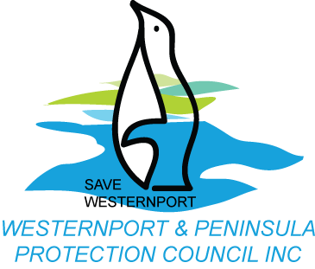

Tourism Research Australia (2011) The Economic Importance of Tourism in Australia’s Regions.

