****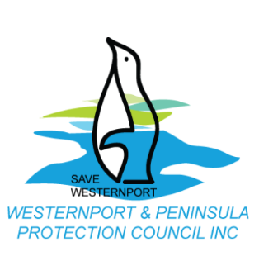





**Community members will rally to oppose the AGL gas import and Kawasaki projects from going ahead in Western Port Bay**

**Media Release 20th June 2018**

Two proposals – the Crib Point AGL gas import project and the Kawasaki Hydrogen Energy Supply Chain pilot project raise community concerns over the environmental, social and economic risks to the values of Western Port Bay.

Save Westernport and Westernport & Peninsula Protection Council are hosting a rally supported by Environment Victoria, the Victorian National Parks Association and Blue Wedges Coalition to voice concerns over two proposals:

* the Crib Point AGL floating regasification project which will ship LNG from around the globe to a floating storage and regasification unit (FSRU);
* the Kawasaki coal to hydrogen pilot project to ship hydrogen to Japan out of Hastings

Save Westernport spokesperson Louise Page says “the project is a short-term measure that has long term consequences for the environment, the local economy and potentially threatens the safety of the local community”.

“There are community concerns over the risk to the high natural values of Western Port Bay, being an internationally significant Ramsar site, providing critical habitat for migratory birds, and home to one of the most southerly extents of mangrove species globally.”

“The project has also been criticised by Victorian and Federal Ministers as being illogical, short sighted and a symptom of a broken gas market and should not go ahead.”

Secondly, the Hydrogen Energy Supply Chain pilot project by the Kawasaki consortium which has already received state and federal funding plans to turn Latrobe Valley brown coal into hydrogen, to ship to Japan.

Louise says “continuing to invest in the dying fossil fuel industry is an equally bad decision at a time when we need to be investing more in rapidly transitioning to the growing market of renewable energy”.

**The risk from the increase in development and shipping from both of these projects will threaten the high conservation and economic value that Western Port provides.**

**The rally will take place at the Fred Smith Reserve, Hastings Foreshore, Sunday 1st July at 1pm and we encourage all concerned community members join in to oppose these two projects.**

Media spokesperson:

Louise Page

Save Westernport

M: 0412 860 606