Please Support…Please Support….Please Support….Please Support

Westernport and Peninsula Protection Council Inc.

Founded in 1971, the programs of the Council are aimed at preserving and restoring our precious natural environment in Westernport Bay and its hinterland. An important part of our activities is to ensure that proper planning processes are observed by Government at all three levels and that community consultation is a fundamental component of planning.
Prompting community awareness of important conservation issues has also been high on our agenda for the past 48 years.
The activities of Council are managed by a committee elected at the annual General Meeting, which is held on a Sunday early in January.
Additional help on the Committee and in a range of other ways is always welcome. Please indicate on the subscription form if you have any special skills or interests which may be helpful in our campaigns.
For further information about our activities please contact: Louise Rawlings: social media 0418 271504, Karri Giles: secretary/editor 59 832 072, Sandy Milne 0419 333 959

I would like to support the work of Westernport Peninsula Protection Council Inc.
Subscription: (not tax deductible) - subscriptions fall due 1st Nov each year
$10 individual $15 family $………
Donation: (tax deductible for amounts of $2 or more - see below) $……….

Computer transfer Westernport and Peninsula Protection Council.
NAB Hastings BSB 083-668
Account number: 02580 2659
Then email with the same details as below on wppcweb@gmail.com so we can send a receipt and include you on our mailing lists
Or send a cheque:
I/we enclose a cheque for: $______ Donation $_________
Name: ……………………………………………………………………………
Address:………………………………………………………………………….Postcode:……………….
Phone:……………………………………………
Do you want your newsletters by email? Email:…………………………………….
Please correspond by email: …….. Please send newsletters by email: ………..
Skills/interests: I would like to offer help in the following ways:
……………………………………………………………………………………………………………
Please return to: Hon Treasurer, WPPC, Box 9, Hastings, Vic 3915

The Westernport Peninsula Protection Council Inc Trust is a gift fund listed on the Register of Environmental
Organisations under Section 78(1) (a) of the Income Tax Assessment Act 1936. Inc. no: A0015886H

Westernport and Peninsula Protection Council Inc
Incorporated Association Reg. No. A15886H ABN 984 610 14730 PO Box 9 Hastings Vic 3915
Newsletter December 2019

WPPC’s AGM Balnarring Hall
3041 Frankston- Flinders Road Balnarring
Sunday 12th January 2020 10.30am

Guest Speaker- Shannon Hurley Marine Campaigner for VNPA
Marine Pests and a Healthy Westernport

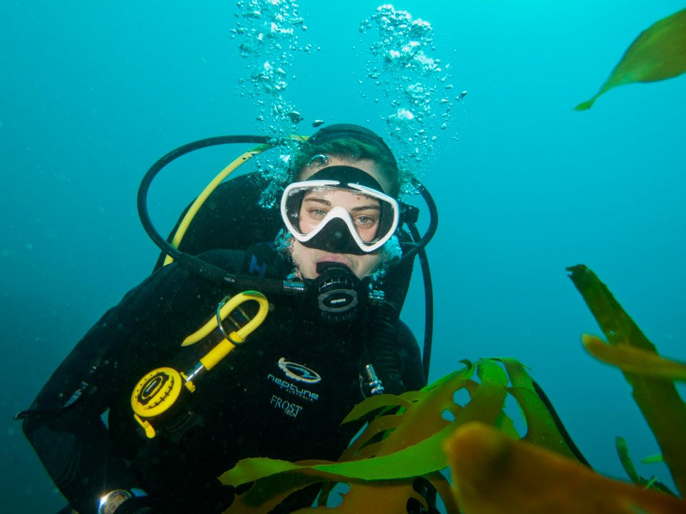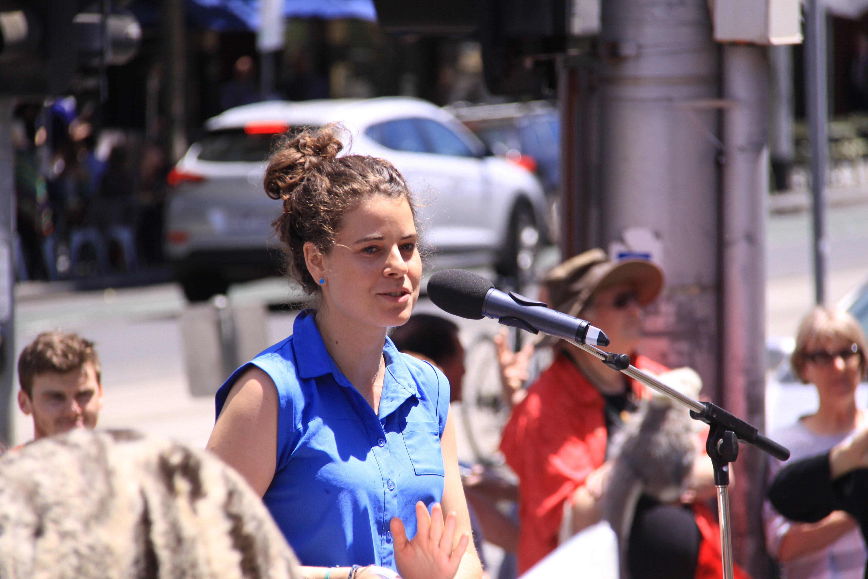

Shannon is the Marine Campaigner for The Victorian National Parks Association. She worked for Parks Victoria undertaking marine planning, monitoring and education, including undertaking the first marine pest monitoring in the waters of Wilsons Prom National Park. She also worked for the Australian Marine Conservation Society to protect the Great Barrier Reef and is a keen scuba diver and passionate about shark conservation and promoting sustainable seafood choices.
WPPC have just received a grant for marine pest monitoring under Bluescope pier as part of the Kawasaki Brown Hydrogen exports out of Hastings. We have a quote from a professional company that has done marine-pest work in Victoria. Shannon will talk about marine pests and a healthy Westernport.
All welcome- Please RSVP to receive lunch to wppcweb@gmail.com

Fossil Frontlines Tour:- In October Save Westernport and WPPC co-hosted Energy Justice Victoria’s Fossil Frontline Tour event, discussing Westernport’s unique, world heritage listed environment and the risks posed by fossil fuel-based development: The Hastings Kawasaki export plant trial - hydrogen from brown coal, and AGL’s proposed floating gas station at Crib Point.

Crib Point Action Group spoke to the Crib Point Community Action Plan. La Trobe Community Power Hub, Environment Victoria and Friends of the Earth discus the work of other communities who have sought and/or established clean and sustainable local alternatives to fossil fuel.

Balnarring Hall was buzzing with ideas from community members, who spoke of their frustration at expensive and unsustainable projects and concerns for the health and environmental impacts of further industrialisation of the bay. People discussed alternatives, including removal of abandoned BP silos local land rejuvenation at Crib Point, community power options, fostering further ecotourism, environmental education and protecting important ecosystems in the Westernport catchment. (Notes taken on the day are now on our website on the Kawasaki page.) By Sandy Milne

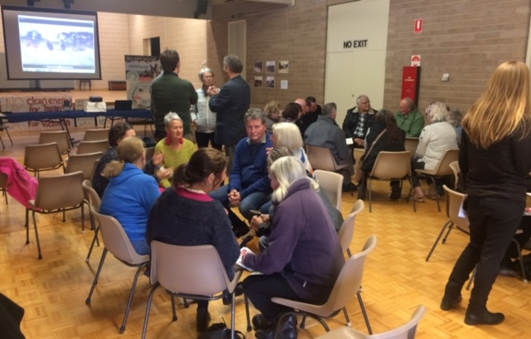
WPPC with Friends Of The Earth, Ninety Mile against Carbon Storage and Energy Justice Victoria protesting at The Environmental Protection Authority about the Hastings Hydrogen Export Plant.
Despite widespread local opposition from communities around Gippsland’s Ninety Mile Beach, arrived in Victoria in November 2019. The Victorian Government says the CarboNet drilling rig will commence on an offshore appraisal well in early December 2019. The rig will be visible from the shoreline and townships of Golden Beach and Paradise Beach at Ninety Mile Beach.
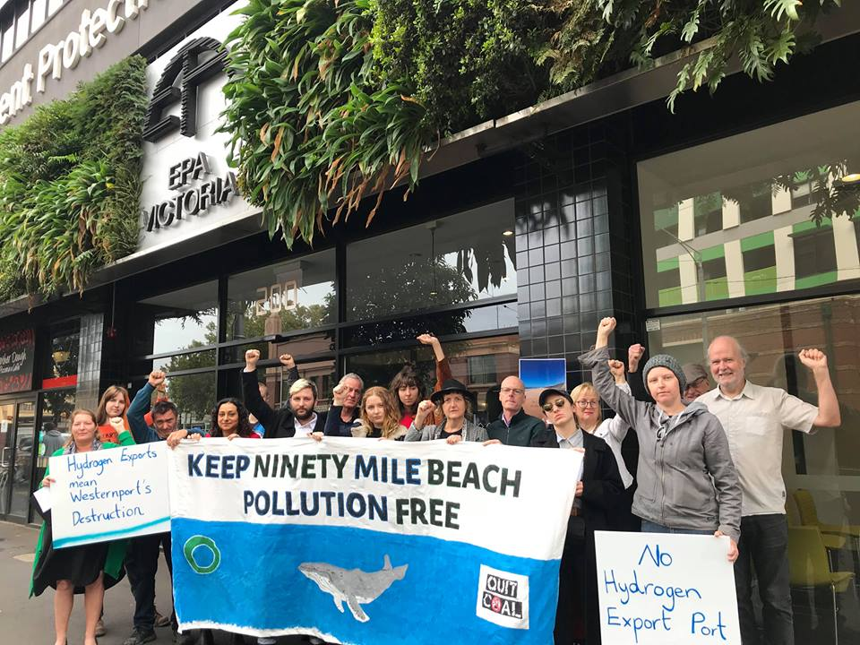

WPPC July 2019 Protest featured in TV news and newspapers:-

On July 19th 2019 WPPC and Save Westernport hosted a peaceful protest against the sod-turning ceremony of the Hydrogen Supply Chain. It was the best use of chanting at any protest I have witnessed. They heard every word, and we made a lot of good points. We stand with many others who have credibly ridiculed this trial. Ronald Brakels from Solar Quotes, Giles Parkinson from Renew Economy, Cat Nadel from Environment Victoria, Mike Seccombe from The Saturday Paper, Peter Gardner from Gippsland Climate News and Views, and NinetyMileagainstCarbonStorage . Dr Soderbaum and Finkel recently questioned its competitiveness versus hydrogen made from renewables. Our protest featured in: The Age, Channel Nine and Channel Ten News and Westernport News whose article is featured below:

Start made on Hastings hydrogen plant
July 22, 2019 Keith Platt
On the other side of the fence and away from the refreshments marquee, protesters from eight environment and community groups show their displeasure at the brown coal-to-hydrogen trial which is being conducted with the help of $100 million of taxpayers’ money.
AN official ground breaking ceremony was conducted at Hastings on Friday (19 July) to mark the start of building a plant to liquefy hydrogen gas for export to Japan.
The plant in Bayview Road is an integral part of the supply chain for hydrogen made from brown coal in the Latrobe Valley to be exported to Japan.
The state and federal governments have each given $50 million towards the $400 million trial that Kawasaki predicts “will create a new innovative technical foundation for the development of an exciting hydrogen export industry for Australia”.

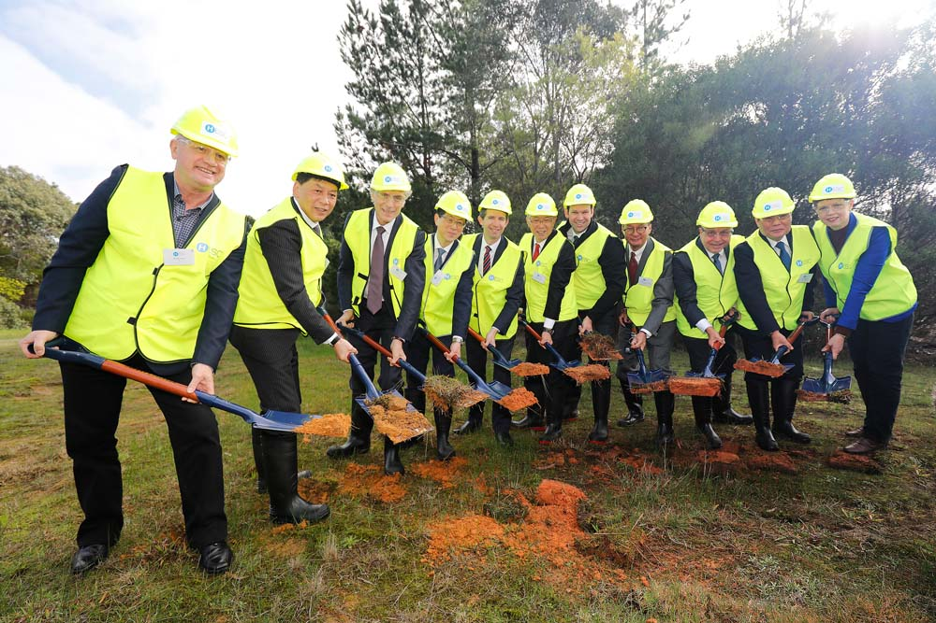
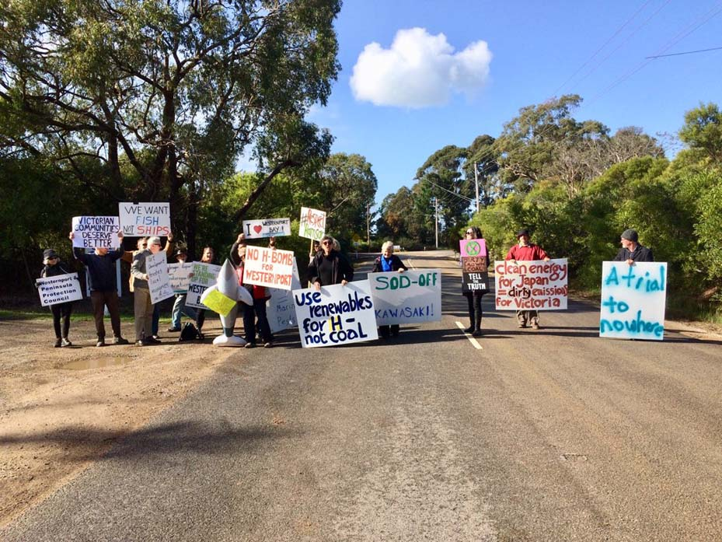
Protesters from eight environment and community groups are unimpressed by such glowing predictions and stood in Bayview Road holding placards and handed out their demands for the return of the $100 million of taxpayers’ money.
The protesters say while motorists overseas benefit from hydrogen power, Australia is left to dispose of the carbon released in the process and Western Port’s environment is in danger of marine pests carried in ships’ ballast.
“Delivering clean hydrogen to the world for the benefit of our environment is a goal we share deeply, and we look forward to achieving,” Kawasaki’s chairman of the board Shigeru Murayama said.
“The hydrogen economy is already materialising in Japan, and it is wonderful to now be breaking ground here in Australia. We are excited to be translating our joint hydrogen vision into reality.”
The line of VIPs pictured turning the first sod included federal Resources Minister Matt Canavan, Minister Matt Canavan, Tourism Trade and Investment Minister Simon Birmingham, the state Treasurer and Economic Development Minister Tim Pallas, Australia’s chief scientist Dr Alan Finkel and Victoria’s lead scientist Dr Amanda Caples.
Notably absent from the line-up were peninsula-based politicians Flinders MP and Health Minister Greg Hunt, Nepean Labor MP Chris Brayne and Hastings MP Neale Burgess.
During his time as environment minister Mr Hunt frequently spoke about the utilising Australia’s vast coal resources and, in mid-2014, predicted technology would be available within three to five years to reduce emissions from coal-fired power stations by 30 to 50 per cent.
Mr Hunt’s office confirmed he “was not in attendance”.
Mr Brayne’s office manager Joshua Sinclair said Mr Brayne had not been invited to the sod turning.
Mornington Peninsula Shire mayor Cr David Gill said he was invited but decided against attending “because it would look like I support the process”.
“What benefit does the public in Australia get from Japanese motorists having clean energy while we keep the carbon that’s left behind,” Cr Gill said.
The hydrogen plant at Hastings includes a liquefaction building and a storage container to be completed by June 2020, with the target of it operating from 2020 to 2021.
Kawasaki says will use its know-how and experiences gained in past liquefied hydrogen and industrial plants to deliver the project safely and on time.
“If the full-scale project is too damaging, expensive and inefficient to go ahead, there is no need for this trial they are celebrating today. As they turn the sod, we say sod-off,” Westernport and peninsula Protection Council secretary Karri Giles secretary said in a news release on Friday.
“Four industrial processes and three journeys make this project ridiculously inefficient when, apparently, making hydrogen in Japan out of water and excess renewables is an option.”
Friends of the Earth campaigns coordinator Cam Walker said the hydrogen project “is entirely dependent on the successful injection and long term storage of carbon waste into the Ninety Mile Beach seabed, yet despite billions of dollars of investment in this technology it has failed to become viable in Australia”.
The group’s coal spokesperson Kate Wattchow sees the brown coal to hydrogen project as “yet another clean coal pipedream, a false-promise to the Latrobe Valley community and an expensive distraction in a time when we need urgent action on climate change”.
Keith Platt First published in the Frankston Times – 22 July 2019

Yuko Fukuma  Senior Staff Officer  Kawasaki Heavy Industries  GHD Level 7 180 Lonsdale Street Melbourne 3000 | The Prime Minister  Hon Scott Morrison  Parliament House  Canberra  ACT 2600 | Hon Jaala Pulford MP  Minister for Agriculture  15 Main Street Ballarat  Vic 3350 | Hon Daniel Andrews  Office of the Premier  1 Treasury place Melbourne  Australia VIC 3002

Please send your email address to wppcweb@gmail.com if you would prefer to receive our annual newsletter by email. Please don’t forget to pay your membership.

POSTAGE PAID AUSTRALIA
PRINT POST
PP 344188/10014
If undeliverable return to:
WPPC
PO Box 9
HASTINGS VIC 3915

Westernport & Peninsula
Protection Council Inc

WPPC Secretary Karri Giles was recognised with an award at Environment Victoria’s 50th Anniversary celebration in Melbourne in October.
Congratulations to Karri, who has been working effectively on the WPPC committee since 1996. Other award recipients were: past committee members of WPPC, Ken and Meredith Hayes, whose daughter Siri collected their award. Also Graeme Burgan from Philip Island Nature Park, Jeff Nottle from Phillip Island Conservation Society, Save Westernport, and The entire Westernport Community also received special recognition.
EV’s wonderful book ‘People for The Planet -The Story of Environment Victoria’ and new film: Thank you! 50 years of Protecting Victoria’s Environment, shows their history, and the many important actions that have protected Victoria’s priceless natural heritage since their earliest days:
- Written by Julia Stockigt,

WPPC Support Save Westernport’s summer campaign against AGL’s gas import facility and LNG pipeline.
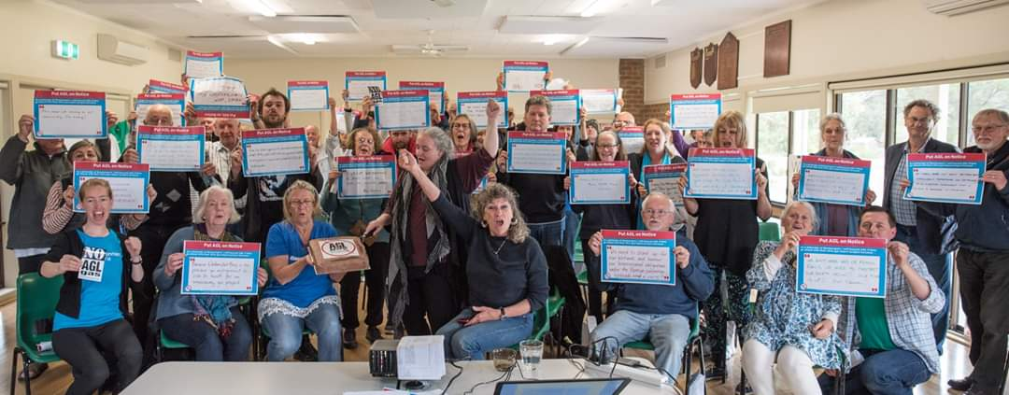

There are two actions you can take
1. Please see Save Westernport or many local retailers for a blank message board for their twitter and Facebook campaign above, then upload your image with #savewesternport @aglenergy #wppcinc

2. Let AGL know you oppose their gas plans, by adding your name to a Pledge Form. If you do not support the plan, you can vow never to be an AGL customer, unless AGL agree to drop this project. If you’re already a customer, you can threaten to dump them as your energy provider. We know Victoria doesn’t need to import gas, and we’ll continue to fight the project until AGL dumps their plans.
Please Put AGL On Notice by signing our Pledge form, available at local shops or sign online or contact Save Westernport at https://savewesternport.org/sign-the-pledge-put-agl-on-notice/ or return it to the address on the Pledge form.

Archive Update
WPPC hosted a working bee to work on the archives thank you all who took time and effort to work to protect this unique resource.
Since then Linda Drewitt has been working with Anna Buchhorn from the Balnarring Historical Society and now the WPPC files are all in good shape. Thanks Anna! Volunteers would be welcome to continue this work.
(Please ring Linda on 0409 602 822)
We will be applying for a 'Local History Grants Program' grant to continue this work. We are also seeking a new venue to house the archives. We want them to remain categorised under ‘Westernport’ rather than split up into separate categories.

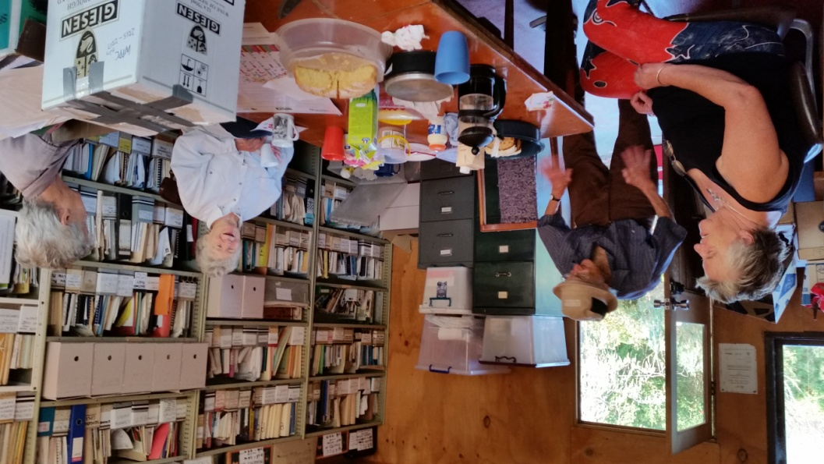

Many Thanks to our retiring Treasurer Henry Broadbent. Henry has done the finances and prepared documents for us for two years. His work is greatly appreciated and we will miss him and Betty as they leave to retire in Sunbury.  We are looking for a Treasurer  – No experience needed. Much of the payments are online and minimal reporting is necessary. We do need someone that is known and has a referee. | Vale Kathie Strickland  She was a member of several groups including WPPC. One thing her husband Peter and she achieved was mapping the vegetation on roadsides for WPPC and pushing for better management of them by The Shire. They published three books about indigenous plants of the Mornington Peninsula, and set up and ran an indigenous nursery.  They also wrote management plans for nature reserves. Her memorial at Coolart was attended by many.

